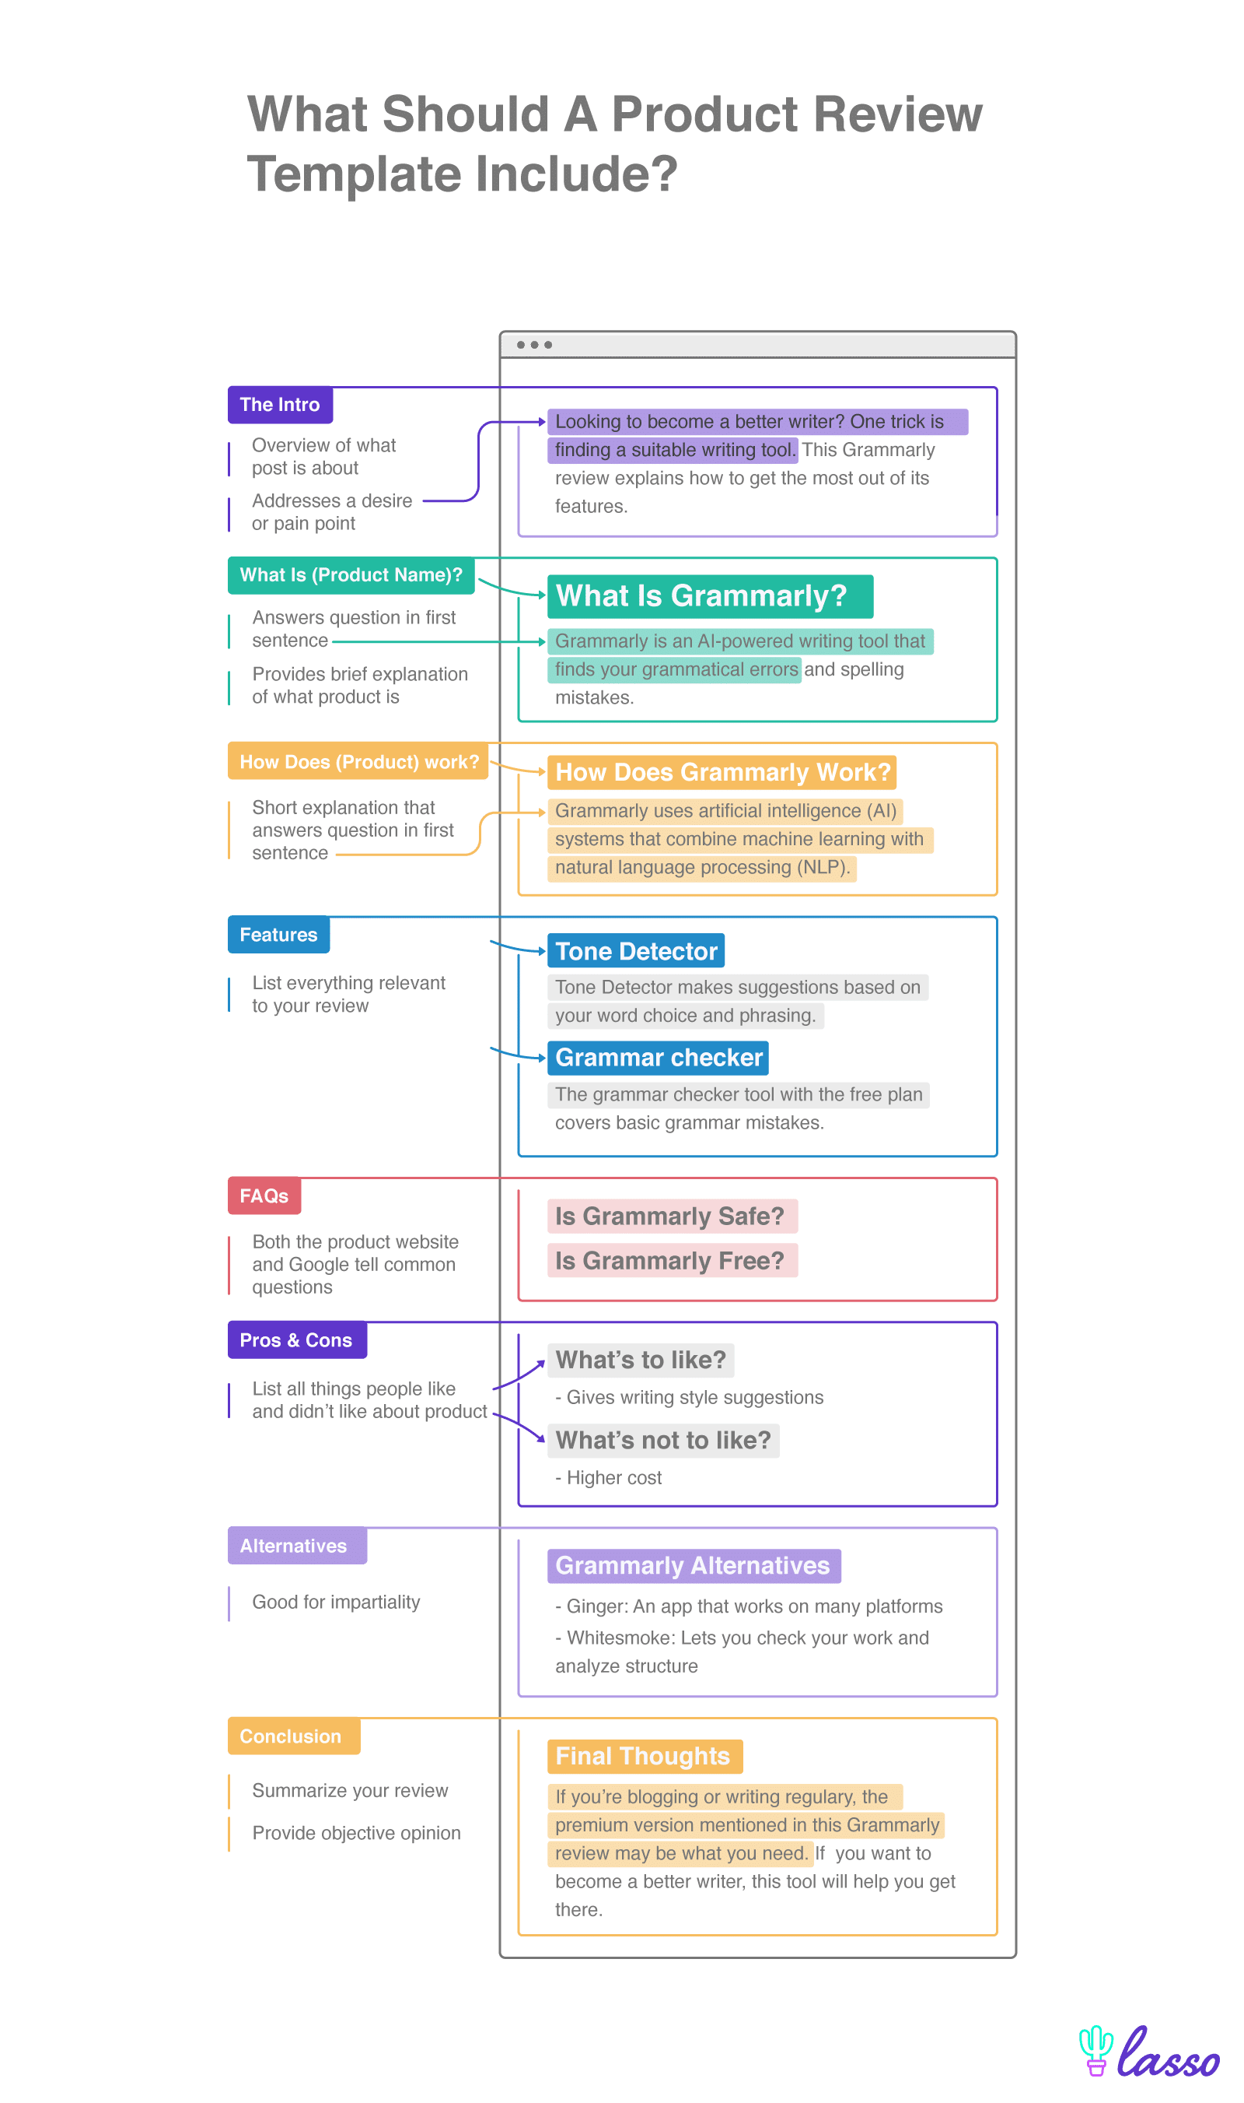

Kindly review this product as per above chart.
Tasco 10x25 binoculars review

