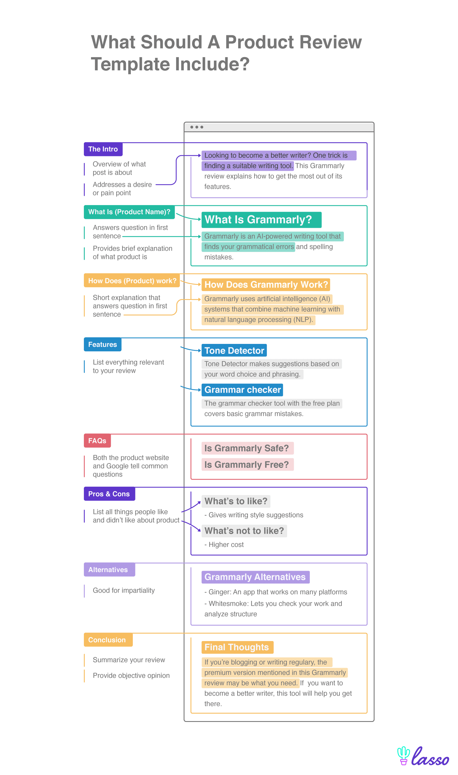

Kindly review this products as per above chart. 1000 words each
1. Zeiss Conquest Compact 10x25 Binoculars Review
2. WTS Leica Ultravid 10x25 BR binoculars Review
3. Cabelas XT 10x25 Binoculars Review
4. Opticron adventurer 10x25 review

